Resume
Nabanita Hazarika. M.A., M.Phil. 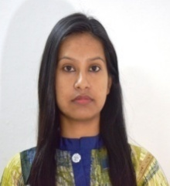
Assistant Professor
Department of English
DKD College, Dergaon
Ph. No.: 9401370276/ 9365504705
e-mail: nabanitahazarika07@gmail.com
Date of joining: 01/01/2021

ACADEMIC PROFILE:
Examination | Institution | Div./class | Percentage/CGPA | Year
H.S.L.C. | Bapuji High School | 1st | 72.5 | 2006
H.S. | Biswanath College | 1st | 80.2 | 2008
B.A. | Biswanath College | 1st | 62 | 2011
M.A. | Gauhati University | 1st | 9.2 (CGPA) | 2013
M. Phil. | Dibrugarh University | NA | B+ (Grade) | 2019
Ph.D. | Dibrugarh University | Pursuing (Registered)

ADDITIONAL QUALIFICATION:
- Have qualified the State Level Eligibility Test (SLET) in English in 2014.
- Have qualified the National Eligibility Test (NET) in English in 2019.
ADDRESS FOR CORRESPONDENCE:
NABANITA HAZARIKA
C/O Dilip Hazarika
Vill.: Balipukhuri
P.O.: Burigang
Dist.: Biswanath (Assam)
PIN: 784176
I hereby clarify that the above is authentic to the best of my knowledge and belief and correctly describes my qualification and myself.
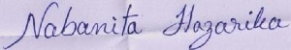
NABANITA HAZARIKA

